d128.wmfWelcome to St Margaret’s Church in Lowestoft. St Margaret’s church has been on this site for many hundreds of years, and during this time has witnessed many thousands of weddings. However, every wedding is special and unique, so whilst we have a long record and extensive experience, your wedding will be designed especially for you.

At St Margaret’s we shall work with you to ensure that not only does your wedding day run smoothly, but that the service is special for you. We will ensure whilst, like everybody else who gets married, you are somewhat nervous, that the service will be a relaxing and enjoyable experience that you will look back on with love and happiness throughout your married life.

**WEDRINGS.WMF**

**Congratulations**

You have already made a fantastic step to ensuring your wedding day is the best it could be by contacting us.

Currently we offer two “packages”:

1. In 2018, a “simple” service which is said, without music or bells, costs £ 500.00
2. A “full” service, including the organ, a maximum of three hymns of your choice, and the bells rung before and after your wedding, costs £795.00. Should you wish to video the service a further £135 is charged.

We shall provisionally book the date and time agreed between ourselves for you. This is held for two weeks, allowing you to contact the Reception venue and others involved in your wedding. If you find you need to change the date, or the time, then give us a ring immediately, and we shall do our best to accommodate you. Within the two weeks you need to confirm your date and time, by sending us a non-refundable deposit of £100.00. Cheques should be made payable to “St. Margaret’s Contingency Fund.” We shall issue a receipt when we receive the cheque. Once you receive this you will know that your wedding date and time have been confirmed.

**THE LEGAL BITS**

At St Margaret’s your wedding is both a spiritual celebration and a legal event. You will arrive at the church as two single people, and leave as a legally married couple. Certain parts of our service therefore are legal requirements.

Before we even arrive at the church there are certain legal requirements: To be married in St Margaret’s either the bride or the groom must be resident within our “parish” or have a strong connection to St Margaret’s. If you are not sure whether your connection is sufficient, do have a word with our priests.

We legally publicise your wedding by calling “Banns of Marriage” on three consecutive Sundays, by agreement, prior to the wedding. If either the bride or bridegroom live in another parish you will also need to get them to publish your Banns of Marriage and then issue you with a certificate confirming that nobody objected to your wedding!

Banns of Marriage are valid for three months, so can not be called any earlier than three months before your wedding.

At St Margaret’s we are happy to consider marrying people who have been divorced, provided they live within the parish. If you have been previously married then we will discuss the particular circumstances surrounding your previous marriage and your new relationship and then let you know if we can marry you. You would need to show us the “Decree Absolute” at our initial meeting.

**WHAT HAPPENS NOW?**

Sometime in November we will write and invite you to an initial wedding preparation morning. We meet in our Church Centre; our priests will be on hand to answer any specific questions you have; we will look broadly at the marriage service so you can start thinking about some of the choices you will need to make. We will listen to the variety of music that can be played at weddings, and the hymns that are most often sung.

**PHOTOS AND VIDEOS**

Your wedding is a special day and you will want to have a record of it. The service may be filmed, though an additional fee is payable to the organist for this. If you are considering having your service filmed do talk with a professional company as there are copyright issues and they will sort everything out for you!

We ask people not to take photographs during the service in order that you can concentrate upon the service and the promises you are making. Your designated photographer is, however, able to take photographs during the service, subject to them standing at the back of the church. Outside the church we try to ensure that you have plenty of time for your photographs. Make sure you capture everybody!

**CONFETTI**

No confetti inside the church please, but once outside we are happy for confetti to be thrown over you.

**WHAT IF I CHANGE MY ADDRESS OR PHONE NUMBER?**

Once you have booked your wedding please do let us know if you change your phone number – this is especially important if all you have given us is a mobile number. If you move house you will need to let us know, especially as we shall have to ascertain that you still live within the parish [please be aware that not every address within Lowestoft is in the parish of St Margaret’s] or you still have a legal connection.

If, and we sincerely hope it doesn’t happen, you decide not to go ahead with your wedding please contact us immediately. We are then able to offer your time to someone else who may want it. If you decide to delay your wedding please contact us as early as possible as we can arrange another date without the need for another £100 deposit!

If you think of any questions, or want more information, please either come along on a Wednesday evening to our Church Centre between 6.30pm and 7.30pm, or phone or e-mail us:

Revd. Michael Asquith Revd. Geoff Wilson

01502 573046 01502 564064

[rector@stmargaretslowestoft.co.uk](mailto:lowestoftstm@aol.com)

**Saint Margaret’s**

**Lowestoft**

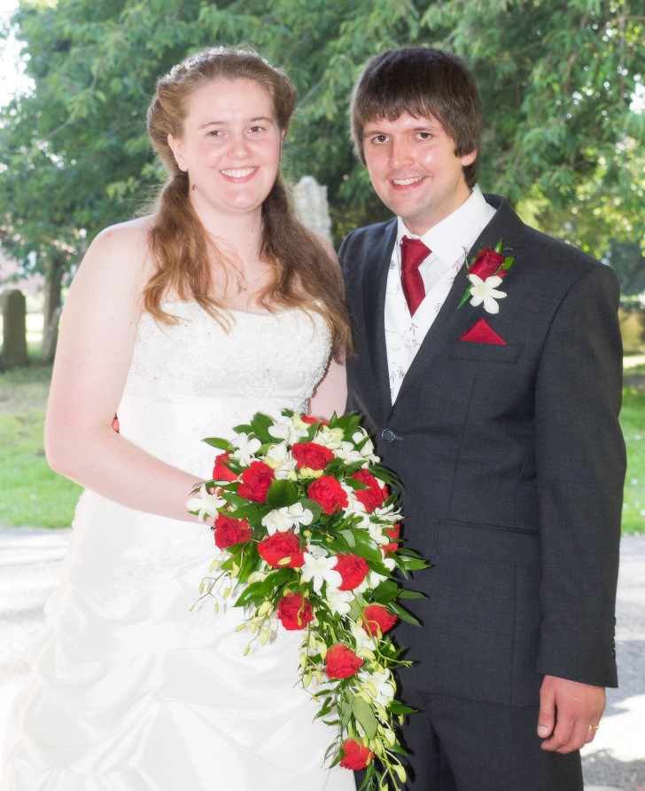

**Our Wedding**